Emily Oh and Lizzie Healy
Chris Braun
Computer Science 106
1 May 2024
Project Report: Wordle in Java

Introduction
In our project, we undertook the challenge of recreating the New York Times game "Wordle" using Java, with an emphasis on implementing fundamental data structures efficiently. We aimed to develop a fully functional version of the game that not only met the requirements of simplicity and efficiency but also served as a practical application of the programming concepts we've studied.
Game Rules:
- User has 6 guesses to guess a randomized 5-letter word.
- Each guess must be a valid word.
- Each guess must be exactly 5-letters in length.
- The color of tiles will indicate how close the guess is to the word.
  - Green letters are in the word and in the correct spot.
  - Yellow letters are in the word, but in the wrong spot.
  - Black letters are not in the word in any spot.
- The game will end if either the user guesses the word correctly or they have used up the six guesses.

Motivation
Our decision to choose this project was driven by a desire to apply our theoretical knowledge in a practical, engaging context. "Wordle," a game many of us play regularly, offered a familiar platform through which we could explore complex programming concepts such as arrays, string manipulation, and algorithm design. The project was seen as an opportunity to demonstrate our proficiency in Java programming and data structures, while also delving into the mechanics of a well-loved game to understand its backend processes better.

Methodology
The architecture of our game includes several classes designed to handle different aspects of the game’s functionality:

1. **Main Class**: Serves as the entry point of the program, where the game loop is initiated and managed. It interacts with the Wordle class to process game rounds and handle user inputs.
2. **Wordle Class**: This is the backbone of our game's logic. It manages the selection of the target word, receives and processes user guesses, and generates appropriate feedback based on the accuracy of each guess. This class uses a combination of loops and conditional statements to compare user inputs with the target word and provides color-coded feedback. Within this class, we implemented an idea outside the realm of this class, which was the use of ANSI color codes. These codes allowed us to highlight certain letters in the output of the code, which was utilized to mimic the part of the Wordle game that returns letters in the correct space as green and letters that are correct, but in the wrong position as yellow.
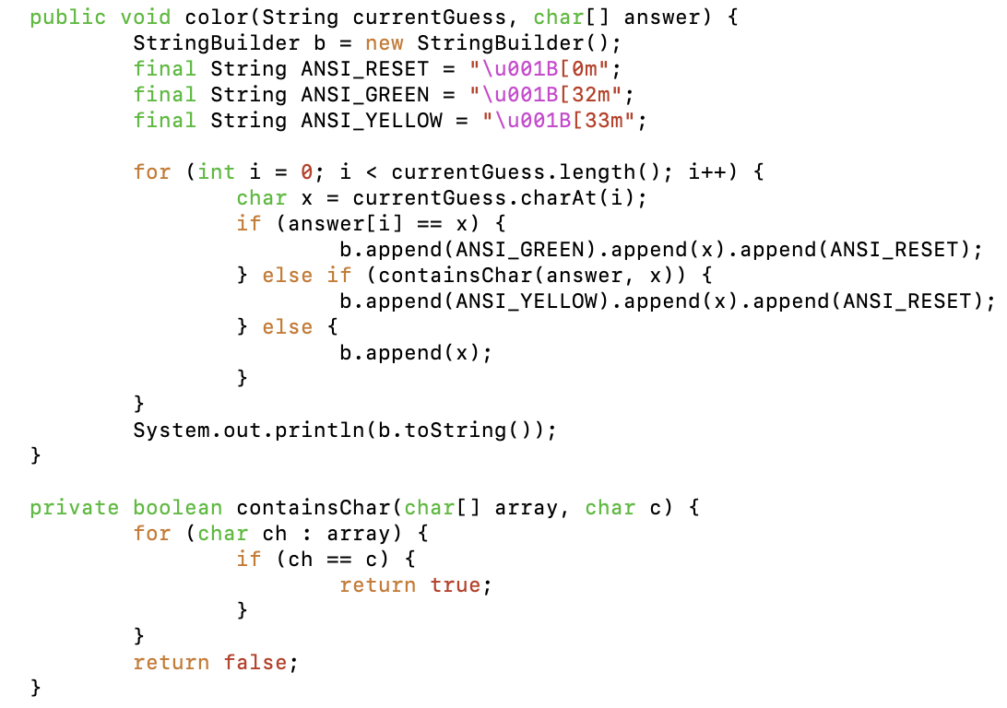
Figure 1: Color Method in Main Class utilizing the new concept of ANSI color codes for highlighted string output.

3. **CSVReader Class**: Handles reading from the 'wordlewords.csv' file, which contains all potential five-letter words. This class ensures that all words used in the game are valid and assists in randomly selecting a target word for each new game session.

In terms of data structures, we primarily used arrays for their efficiency in storing and accessing data. Arrays were ideal for our needs because they allow quick access to their elements, which is essential for checking letters and their positions during the game. In addition, the size of the array is always known and we have no need for insertion or deletion from interior positions of the array, thus an array is the optimal structure for our program design.
The additional libraries we utilized are the Scanner class and the Random class. Firstly, the Scanner class is generally used to get user input through command-line arguments and in the case of our project, the scanner was used to receive the user’s word guess within the Main class. Secondly, the purpose of the Random class is to generate pseudorandom numbers, which was implemented to choose a random word from the read-in list of 5-letter words to use as the answer for each iteration of the game.

Results
The game operates via a command-line interface, which provides a straightforward and interactive user experience. Players enter their guesses, and the system responds in real-time, offering feedback after each submission. This feedback includes color-coded indications: green for letters that are correct and correctly placed, and yellow for correct letters that are misplaced. Below is an outline of the sequence of the gameplay with descriptions of the different tracks the game may take depending on the user input.


Figure 2: The initializing of the game, the game is now ready to accept a command-line argument from the user.
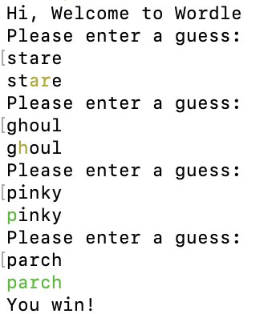
Figure 3: How the game progresses if the user guesses the correct word before the six guesses are up. The green highlighting indicates the correct letter in the correct place, the yellow highlighting is the correct letter in the wrong place, and black indicates the wrong letter altogether.
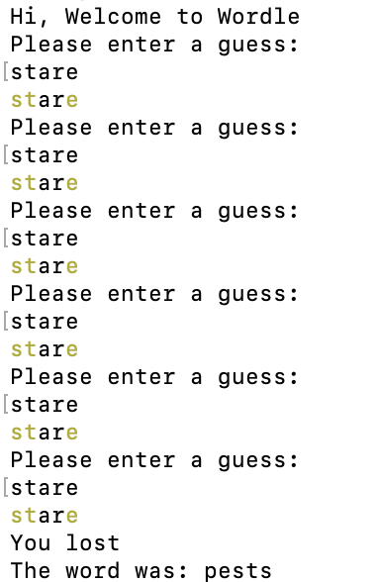
Figure 4: How the game progresses if the user guesses six times without getting the correct word. The game automatically ends and lets the user know they have lost.

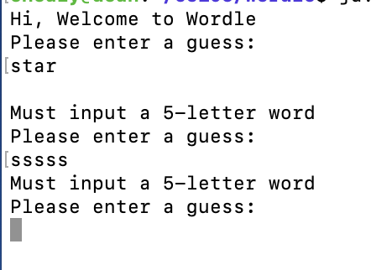
Figure 5: If the user inputs less than or more than five-letters, the game will prompt the user for a five-letter guess without utilizing a guess. If the user guesses a word that is not a word, the game will prompt the user for a real-word without using on the user’s six game guesses.

Discussion
The project posed several significant challenges. The first was managing the array of five-letter words efficiently—particularly, ensuring that operations like search and update were performed optimally to maintain quick response times during the game. Another challenge was developing a clear and effective user interface on the command line, which required thoughtful design to make the feedback both intuitive and helpful.
These challenges were beneficial as they pushed us to explore more in-depth aspects of Java programming, such as advanced array manipulations and enhancing user experience through effective interface design.

Conclusion
This project was a valuable opportunity for us to apply and extend our knowledge of Java and data structures in a real-world application. The experience deepened our understanding of both the theoretical and practical aspects of software development, particularly in the context of game design. By addressing the challenges encountered, we gained insights into optimizing code efficiency and improving user interaction, which are critical skills in software development.

